Name: ______________________ Date: ________
Fill In Proofs Day 3
1. Given: ∠ 1 = ∠2
Prove: ∠ ACB = ∠ADE
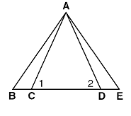
2. Given: AB = DE
Prove: AE = DB
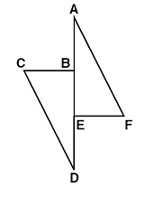
3. Given: ∠BCE = ∠DCE
Prove: ∠BCA = ∠CDA

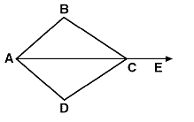

4. Given: PB = EA
Prove: PA = EB
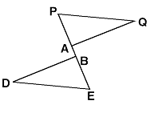

5. Given: ∠CAB = ∠DBA
DA bisects ∠CAB
CB bisects ∠DBA
Prove: ∠1 = ∠4

